ST. MATTHEW’S SAFEGUARDING TEAM
Keeping children safe is our number one priority. We ensure that the safety and wellbeing of every child is at the centre of every decision we make. If you have any concerns regarding the safeguarding of children, please speak to us!

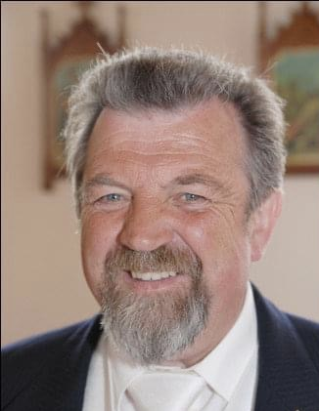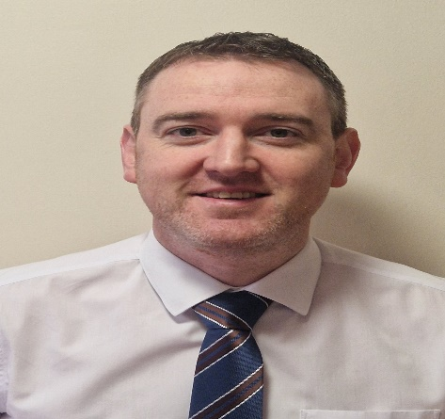
Liam Begley Diarmuid Barr
Chairperson of the Board of Governors Designated Governor for Child Protection

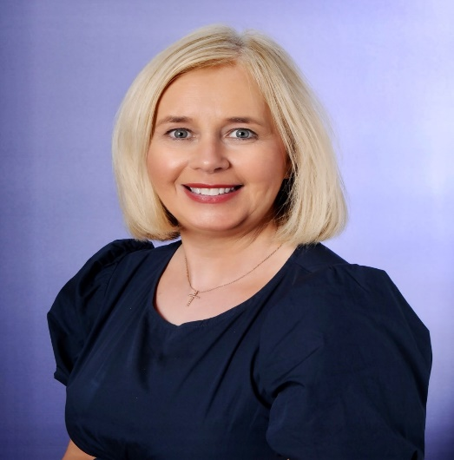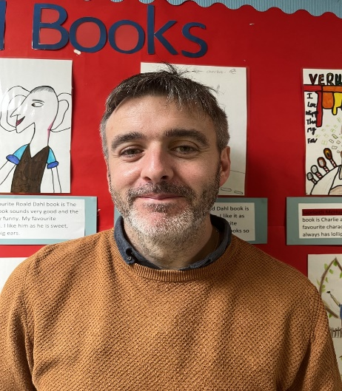
Ann-Marie Kealey Tyrone Proctor
Principal Deputy designated Teacher for Designated Teacher for Child Protection Child Protection

