**April/May News 2021**



**Split the Pot**

We will be starting a new fundraiser Split the Pot. Small envelopes will be sent home in homework folders. If you or your extended family wish to enter the draw place £1 in the envelope and clearly mark it with your name and contact number and return it to the box in the school foyer or class teacher. The draw will take place each Friday afternoon and the winning envelope drawn will receive half the value collected that week, the other half will go towards school funds. The first draw will take place Friday 7th May. Winners will be contacted to collect their prize.

**Staff Updates:**

**We wish to welcome Mrs Vail back from maternity leave.**

**Miss Daniels was married over the Easter break she is now Mrs McKeown.**

**School Nurse:**

**The school nurse has issued letters to P1 and P2 parents. Please complete the form and return it to school.**

**Important Dates:**

School is closed Monday 3rd May.

School is closed Wednesday 26th May – Wednesday 2nd June. School reopens Thursday 3rd June.

**Confirmation 19th June provisional date, time to be confirmed.**

**First confession and First Communion no dates available yet.**

**Service of Light no dates available yet.**

**April/May 2021**

**Classroom learning**

Formal tests or assessments will take place the week beginning 10th May. Any gaps and next steps will be identified and addressed as learning moves forward in a planned and supportive way.

|  |
| --- |
| **Important Reminders**  If your child is sick, do not send them to school  Ensure anyone with COVID-19 symptoms does not attend school  Please also make us aware if your child develops COVID -19 symptoms, if you have booked a COVID test and are awaiting results.  Wash hands thoroughly and more often than usual.   Promote respiratory hygiene using the ‘catch it, bin it, kill it’ approach  Minimise contact and maintain social distancing when possible – stay in your bubble |

|  |
| --- |
| **School Contact**  During all face-to-face teaching times, parents will be communicated with in the usual ways. If there are any issues etc. please contact us at school as normal. |

**Thank You!**

We would like to thank everyone who bought tickets for the Easter Hampers. With your help we raised £312.

Gelvin Community Group have printed a new book “Those were the days” Memories from Primary School. Copies are available from Eugene McCloskey 07593083956 cost £10.

**After School Clubs**

Breakfast Club from 19th April

Breakfast Club has restarted from

Monday 19th April 8am – 8.45 am. The cost is £1 per child per day or £4 for the week payable Monday.

**Mondays From 26th April** [](https://www.google.co.uk/url?sa=i&url=https://www.freepik.com/free-photos-vectors/sports-ball&psig=AOvVaw36r9y4pKCCXqvBI7rPZL0b&ust=1605011159180000&source=images&cd=vfe&ved=0CAIQjRxqFwoTCNCxpNK69ewCFQAAAAAdAAAAABAE)

**Multi Sport Club**

P1 – P3 2pm – 3pm

P4 – P7 3pm – 4pm

**Wednesdays from 28th April** [](https://www.google.co.uk/url?sa=i&url=https://www.monaghangaa.ie/2018/03/u14-hurling-development-squad-trial-coming-friday-11am-1pm-cloghan/&psig=AOvVaw3AX-Q97ocnw_Kr4t-EyJXA&ust=1619529344029000&source=images&cd=vfe&ved=0CAIQjRxqFwoTCODDgYz_m_ACFQAAAAAdAAAAABAK)

**Camogie and Hurling Club**

P4 – P7 pupils. 3pm – 4pm

Coaches: Seana McGonigle and Shauneen Mullan

**Thursdays from 29th April**

[](https://www.google.co.uk/imgres?imgurl=https://previews.123rf.com/images/krisdog/krisdog1602/krisdog160200001/51882880-deux-enfants-de-bande-dessin%C3%A9e-gar%C3%A7on-et-fille-danse.jpg&imgrefurl=https://fr.123rf.com/photo_51882880_deux-enfants-de-bande-dessin%C3%A9e-gar%C3%A7on-et-fille-danse.html&tbnid=M3Aj4piv1ARdOM&vet=10CBoQxiAoCGoXChMIyP6a46id7AIVAAAAAB0AAAAAEBI..i&docid=1QA6u5rwp6TT7M&w=1300&h=943&itg=1&q=Dancing%20child&safe=active&ved=0CBoQxiAoCGoXChMIyP6a46id7AIVAAAAAB0AAAAAEBI)

**Dance Club**

P1 – P3 2pm – 3pm

P4 – P7 3pm – 4pm

All children should be collected from

the Front Door. Please ensure you collect your child promptly as the coaches need to leave promptly.

**School Collection**

Thank you to everyone for following our “pick up” rules. Our children’s safety is our first and main priority. Please, wear a face mask and adhere to social distancing rules when collecting children.

P1 – P3 pupils can be collected from the staff car park.

P4 – P7 pupils will be brought in class bubbles. Pupils must be collected from bottom of school lane, parents must cross over and then cross safely with lollipop. Social distancing must be adhered to and masks worn when collecting or dropping off your child/children

**Thank You!**

We would like to thank everyone who donated to SVDP. With your help we raised £500

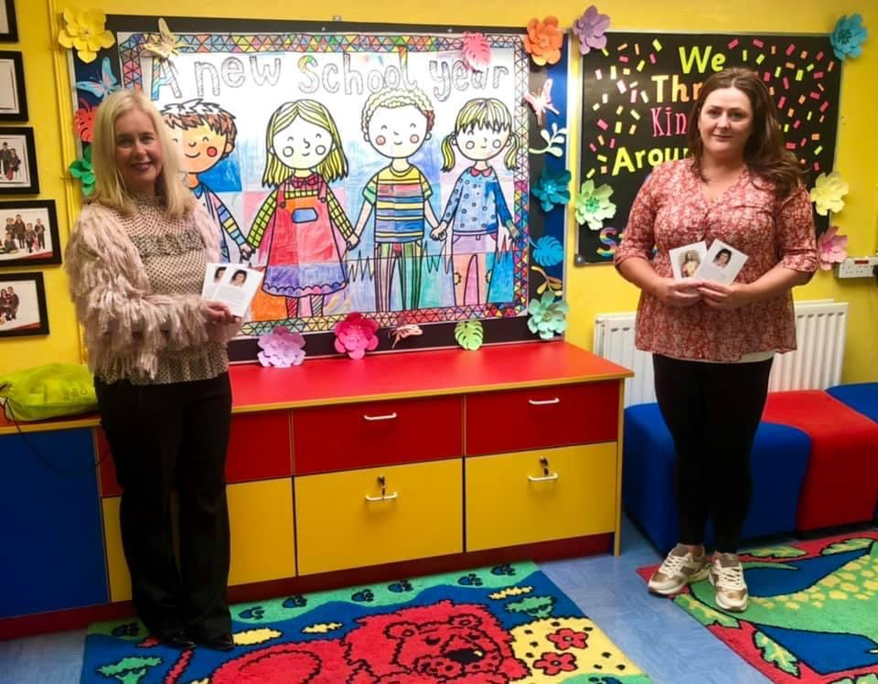

Thank you so much to Laura Hasson who came to visit St Matthew’s last week to deliver beautiful prayer books and Rosary Beads.

**Schoolbags etc.**

We continue to follow guidelines to reduce what travels between home and school.

Children should not bring a schoolbag.

All pupils use the wipe-able plastic folders supplied earlier in the year for materials that need to travel

Water bottles should be washed in warm soapy water daily along with lunchboxes if your child is not taking dinner. Disposable paper bags for lunch are also still welcome.

Lunch bags should also be wipe-able rather than cloth.

**What happens if my child’s class has to self-isolate? (Based on most up to date PHA guidance.**

In the event that there is a positive COVID result within your child’s bubble, the class will have to self-isolate for 14 days. Your other children are not expected to isolate – just children in affected bubbles. Further guidance can be found overleaf – a very useful document from PHA and Department of Education.

**How will my child keep up with school work?** Should this happen, school work and other class messages will be circulated via ***Seesaw.*** During a period of self-isolation, children will continue with spelling activities, reading activities and any additional activities. Your child’s teacher will also give instructions on tasks to be completed.