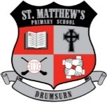 | St Matthew’s Primary School  296 Drumsurn Road  Limavady  BT49 0PX  Telephone 028777 63887  Email: akealey695@stmatthewsps.drumsurn.ni.sch.uk  Principal : Mrs AM Kealey BA Hons (ED) PQH NI

07/09/2020
Dear Parents
As we begin our second week back to school with everyone, I just wanted to say that it has just been really wonderful to welcome all our children back! It has been such a long time since we have all been together and it was just fantastic to see everyone again. The children are all just so happy to be back too and are well settled into their classrooms again.

Firstly, I would like to thank you all for your support so far with our re-opening plans, especially following our new guidelines, including collections and drop-offs. Staff have been going above and beyond every day to make sure the school is extra safe and clean for everyone. Our first week has been a huge success – so from the bottom of my heart – THANK YOU!
This letter just highlights a few points / reminders for our entire school community.
DATES FOR YOUR DIARY
Our new revised holiday list is almost finalised and will be issued this week. Please note that Friday 25th September is a teacher training day and school will be closed to all pupils.

CHILD PROTECTION AND SAFEGUARDING TEAM
The Board of Governors and staff of St. Matthew’s P.S work in unison to act professionally and to provide a safe and supportive environment, which secures the well-being and the very best outcomes for the pupils in their care.
If you, as a parent/guardian, wish to raise a concern or complaint about a Child Protection matter, please contact one of our safe guarding team.
Mr Liam Begley- Chairperson of the Governors
Mrs Ursula Hamill - Designated Governor for Child Protection
Mrs Kerry Ann Mc Gurk -Designated teacher for Child Protection
Mrs Ann-Marie Kealey-Principal/Deputy Designated Teacher for Child Protection

HOMEWORK 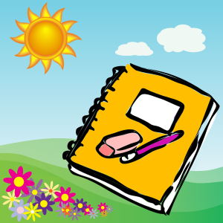
Current guidelines expect that we find ways to REDUCE and LIMIT the exchange of materials between home and school. We know this exchange of materials can never be eliminated. Schools are doing their best to find different ways to reduce this. It only takes one pupil, parent, family member or carer to test positive to make us think about what is essential and help make sensible choices. We appreciate your understanding during current times. It is everyone’s responsibility!

Formal written homework will begin on Monday 14th September. A homework planner for children will be included in their individual plastic folders which will be given out next Monday. Written homework and reading books will be sent home with pupils on a Monday, however, in order to limit the items coming back into school, homework will be completed at home by the pupils and returned together with reading books to school on Thursdays.
Teachers will continue to also use SEESAW to share some school work. It is important to keep this form of communication active too.
FIRST CONFESSION AND FIRST COMMUNION
We are excited in school to begin our preparations for First Confession and First Communion.
Our Primary five class will make their First Confession in St. Matthew’s Church on Monday 28th September at 11am. They will also make their First Holy Communion on Saturday 10th October at 11am in St. Matthew’s Church too. Five family members including the child can attend for each sacramental celebration. More details will follow!

COVID REMINDER
REMEMBER….
In order to ensure that we, as a school, can remain open for as long as possible, please DO NOT SEND YOUR CHILD TO SCHOOL IF:
- They have a continuous cough
- They have a high temperature
- They have a loss of their normal sense of taste and/or smell.
- Please keep your child at home if they are unwell, thank you to our parents who are already adhering to this.
Please remember, if you need something urgent answered, please contact me at school and I will do my best to get back to you as soon as possible.

Many thanks for all your continued support and cooperation.

Mrs AM Kealey Principal

