St Matthew’s Primary School
BT49 0PX
Telephone 028777 63887
Email: akealey695@stmatthewsps.drumsurn.ni.sch.uk
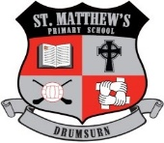
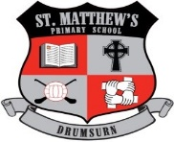
Principal : Mrs AM Kealey BA Hons (ED) PQH NI

Dear Parents/Guardians,

As many of you are currently aware from the news today, schools will close on Friday 16th October for an extended Halloween break in order to provide a 'circuit breaker' in controlling the spread of Covid-19. Schools plan to reopen for pupils on Monday 2nd November.

P1 Parents meetings and Educational Plan meetings will be rescheduled for a later date after Halloween.

The Minister for Education has stated that this is an extended holiday period, therefore no remote learning is required. However, to be prepared for all eventualities (if this time at home is extended beyond the 2nd of November) children should keep their homework packs at home at present and teachers will continue to use Seesaw as a remote learning platform after Halloween.

Thank you for all your support in ensuring our school community stays safe in these very difficult times for us all!

Take care and keep safe everyone,

Kind Regards

Mrs Ann-Marie Kealey

Principal

