March News 2021
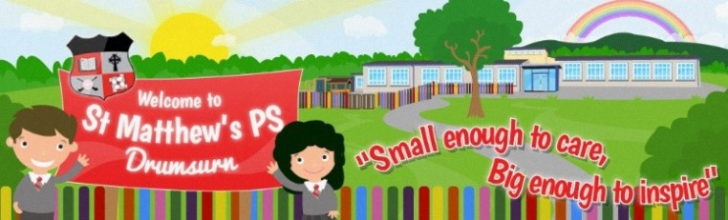
March 2021

Classroom learning
As all children return to school there will be a strong focus on ensuring the children enjoy and engage in lots of learning experiences when back in school. Children's emotional health and well- being, reconnecting with friends and spending time adjusting to school life again will be our priority. No formal tests or assessments will take place until May time. Any gaps and next steps will be identified and addressed as learning moves forward in a planned and supportive way.

Important Reminders

If your child is sick, do not send them to school
Ensure anyone with COVID-19 symptoms does not attend school
Please also make us aware if your child develops COVID -19 symptoms, if you have booked a COVID test and are awaiting results.

Wash hands thoroughly and more often than usual.
Promote respiratory hygiene using the ‘catch it, bin it, kill it’ approach
Minimise contact and maintain social distancing when possible – stay in your bubble

School Contact
During all face-to-face teaching times, parents will be communicated with in the usual ways. If there are any issues etc. please contact us at school as normal.
Lent:
Lent has started and during Lent we ask you
not to send your children to school with
chocolate or sweets. This is to help those
children who are off these things for Lent.

Easter Draw
We are holding an Easter Draw for 2 Easter Hampers donated to school by Lorraine Mullan. Tickets costs £1 per strip and can be purchased from the class teacher. The draw will take place on Tuesday 30th March.
Thank You!
We would like to thank everyone who donated to SVDP. With your help we raised £500

Important Dates:

School closes at 11.30am Wednesday 31st March for Easter Break. School is closed 1st April – 11th April and re-opens 8.45am Monday 12th April.

Holy Communion 15th May time to be confirmed.
Confirmation 19th June time to be confirmed.
First confession and Service of Light no dates available yet.

Welcome back, we are so happy to have all our pupils back at school. We really missed you all! We love to hear the sound of your chitter chatter in the classrooms and in the corridors.

A new dinner menu has been sent home today, we are on Week 3
Wedding Bells
Miss Daniels is getting married over Easter Break. She finishes on Friday 26th and will be back after Easter Break.

After School Clubs
There will be no Before or After Schools Clubs until we get updates from Department of Education that it is safe for them to return.

School Collection
Thank you to everyone for following our “pick up” rules. Our children’s safety is our first and main priority. Please, wear a face mask and adhere to social distancing rules when collecting children.
P1 – P3 pupils can be collected from the staff car park.
P4 – P7 pupils will be brought in class bubbles. Pupils must be collected from bottom of school lane, parents must cross over and then cross safely with lollipop. Social distancing must be adhered to and masks worn when collecting or dropping off your child/children
Thank You!
We would like to thank everyone who donated to SVDP. With your help we raised £500

Staff Changes
Mrs Vail returns from Maternity leave on Monday 29th March which unfortunately means that Miss Begley’s last working day with us is Friday 26th March. We will be sorry to see her go but wish her well in her next teaching post.

Schoolbags etc.
We continue to follow guidelines to reduce what travels between home and school.
Children should not bring a schoolbag.

All pupils use the wipe-able plastic folders supplied earlier in the year for materials that need to travel

Water bottles should be washed in warm soapy water daily along with lunchboxes if your child is not taking dinner. Disposable paper bags for lunch are also still welcome.
Lunch bags should also be wipe-able rather than cloth

REMAINING HOLIDAY’S  (School closes 11.30am Wednesday 31st March)  Thursday 1stApril– Friday 9th April.  (school re-opens Monday 12th April) | Easter Holidays
Monday 3rd May | May Day
Wednesday 26th May - Wednesday 2nd June.  (School re-opens Thursday 3rd June) | May Bank holiday and Teacher Training
School closes 11.30 am Wednesday 30th June for Summer!

We’re Going Back to School

We’re going back to school; we might feel sad to say goodbye,
But friends are just like sunshine – they will help the tears to dry.
We’re going back to school; we might feel nervous at the door,
But joy will soon take over when we see our class once more.
We’re going back to school; we might forget a rule or two,
But soon we will remember as we gently talk them through.
We’re going back to school; we might do things a different way,
But new will turn to normal as we practise day by day.
We’re going back to school; we might not say that we are scared,
But don’t forget: a problem gets much smaller once it’s shared.
We’re going back to school; we might have grown-ups who are new,
But we will get to know them and they’ll get to know us, too.
We’re going back to school; we might be facing things unknown,
But doing them together means we’ll never be alone.
We’re going back to school, where we will laugh and learn and play,
Then head back home for cuddles once we’ve had a lovely day.
What happens if my child’s class has to self-isolate? (Based on most up to date PHA guidance.
In the event that there is a positive COVID result within your child’s bubble, the class will have to self-isolate for 14 days. Your other children are not expected to isolate – just children in affected bubbles. Further guidance can be found overleaf – a very useful document from PHA and Department of Education.
How will my child keep up with school work? Should this happen, school work and other class messages will be circulated via Seesaw. During a period of self-isolation, children will continue with spelling activities, reading activities and any additional activities. Your child’s teacher will also give instructions on tasks to be completed.

