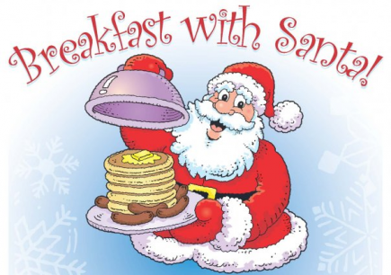
PTA FUNDRAISER

We invite parents, children, grandparents, extended families, and friends of St. Matthew’s Primary School community to come and join us for Breakfast with Santa on Friday 9th December 2022. There will be a choice of cereals, sausage or bacon baps and pancakes with various toppings, breakfast juice and hot drinks to choose from.

Santa will join us too for breakfast and will be available to chat to children individually in his grotto. Children will have the opportunity to visit Santa as soon as they’ve finished breakfast. Due to the high demand last year, we will have three breakfast sessions 8am, 9am and 10 am (children coming for the 10am session do not need to be in school until then). Tickets will be allocated on a first come first served basis.

Children's breakfast with visit to
Santa’s grotto, photograph and selection box. £5 per child.
Adult breakfast £5 per adult.

This is a ticket only event - If you would like to join us, please complete the attached reply slip and return it to school with payment. The elves need to know how many selection boxes to put on the sleigh. Tickets will then be sent home.
Please note normal breakfast club will not be on this day and children can wear their Christmas Jumpers too!
--------------------------------------------------------------------------------------------------------------------------------------
Booking Form Please return before Friday 2nd December.
Child’s Name: ___________________________
Time preferred: 8am [ ] 9am [ ] 10am [ ]
Number of children’s
breakfasts: _______________ [ ] Number of Sausage baps [ ] Number of Bacon baps
Number of
Adult’s breakfasts: _________ [ ] Number of Sausage baps [ ] Number of Bacon baps

Any special dietary / allergy requirements:_____________________________________

I have enclosed £5 per ticket

Signed: _________________________

