Junior Entrepreneur 2019
St. Matthew’s PS Drumsurn - Showcase Day
Friday 12th April

P6/7 pupils are asking you to support them in their business venture.

‘Smiles ‘n Styles Hair & Nail Salon
Hair £3.00/Nails £2.50
£5.00 for both
&
‘Crystal Clear Car Wash’
£4.00
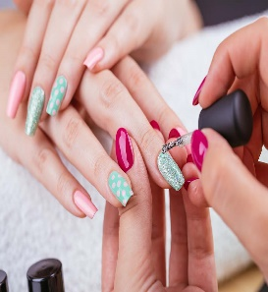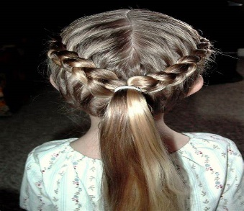
9.30am – 2.45pm
Please support us!

